Mikrotik Configuration

Auto Failover Using Recursive Route/Routing Technique

Pre-Design without Full Label - Two Mikrotik Router connected to the Cloud Net turned on.

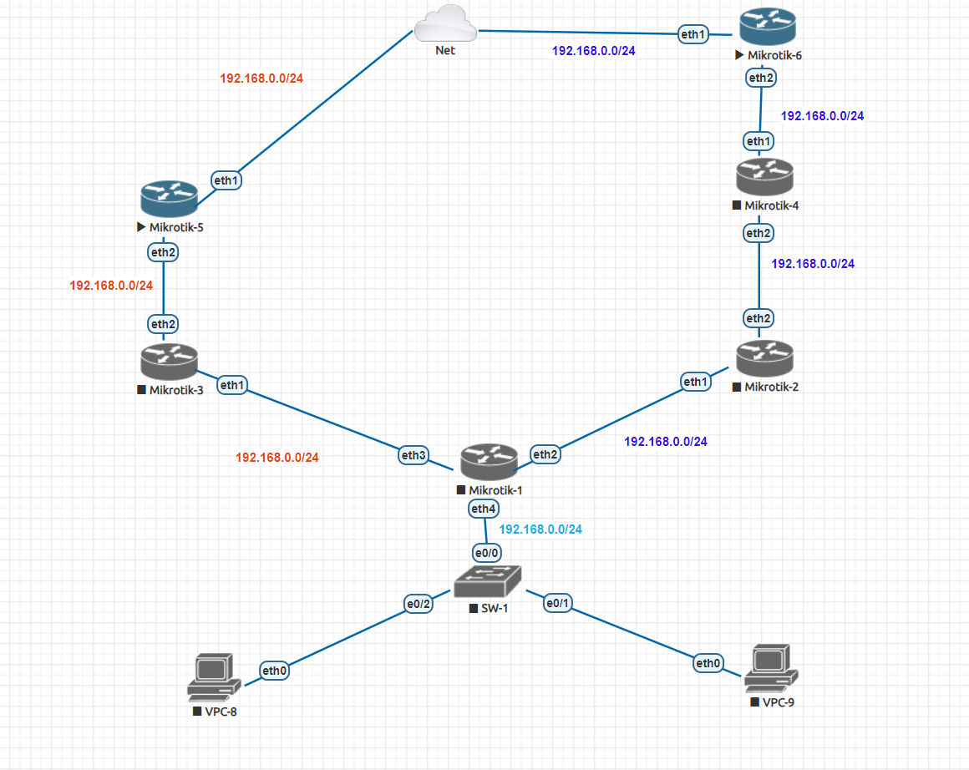

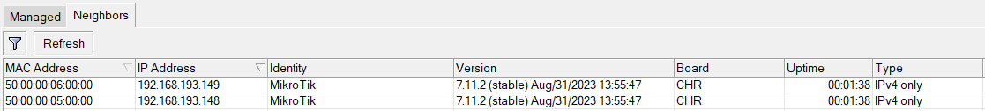

Change Mikrotik Router Identity for Correct identification as it is on the Topology

Change Mikrotik-5 router

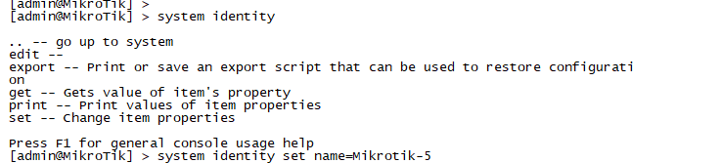



Check for Internet reachability

